# Lab: Single Page Application

Problems for exercises and homework for the ["JavaScript Applications" course @ SoftUni.](https://softuni.bg/trainings/4228/js-applications-october-2023)

**Working with Remote Data**

For the solution of some of the following tasks, you will need to use an up-to-date version of the **local REST service**, provided in the lesson’s resources archive. You can [read the documentation here](https://github.com/softuni-practice-server/softuni-practice-server).

## Simple Calendar

## Calendar

Write a program that navigates through different views on a calendar, depending on your choice. You will be given HTML and CSS code with the views for different years along with their months and days.

### Screenshots

Year selection view – contains a list of years. Clicking the desired year should display the view, containing the months for that year.

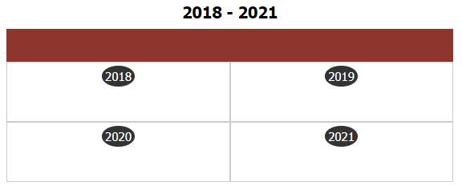

Yearly view – contains a list of months for the selected year. Clicking on any of the months should switch to the monthly view. Clicking the year (top part of the table) while in the yearly view returns the user to the list of years.

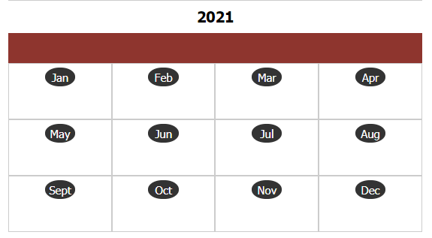

Monthly view – contains a calendar with all dates for the selected month, arranged as weekdays. Clicking the month (top part of the table) while in the monthly view returns the user to the list of months.

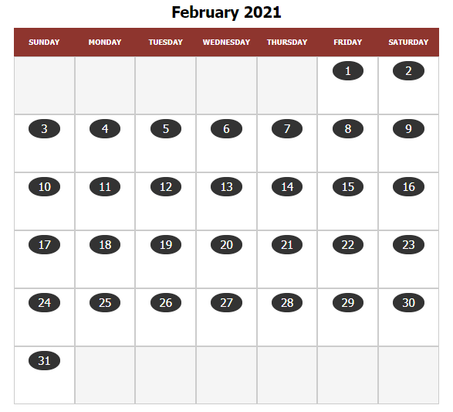

## Cookbook – Part 3

The resources for this task are available in the following GitHub repository:

<https://github.com/viktorpts/js-apps-workshop>

You may check-out the repository or download the files via the green button labeled “Code” in the upper-right corner. Use the files located in **lesson-04/base** to begin the task. Before starting, make sure you have the most recent version of the repository. To see the solution, check the files inside **lesson-04/finished**.

Let's write more functionalities for this task and extend the application. In this task we will write the functionalities for editing and deleting recipies.

### Code Refactoring

Rewrite the application, so that it is a single-page application, using modules with import/export statements. There will be a single HTML file, containing all resources and the views will be dynamically generated via JavaScript.

### Recipe Details

Instead of expanding in the Catalog view, clicking on a recipe preview changes the view to a details page.

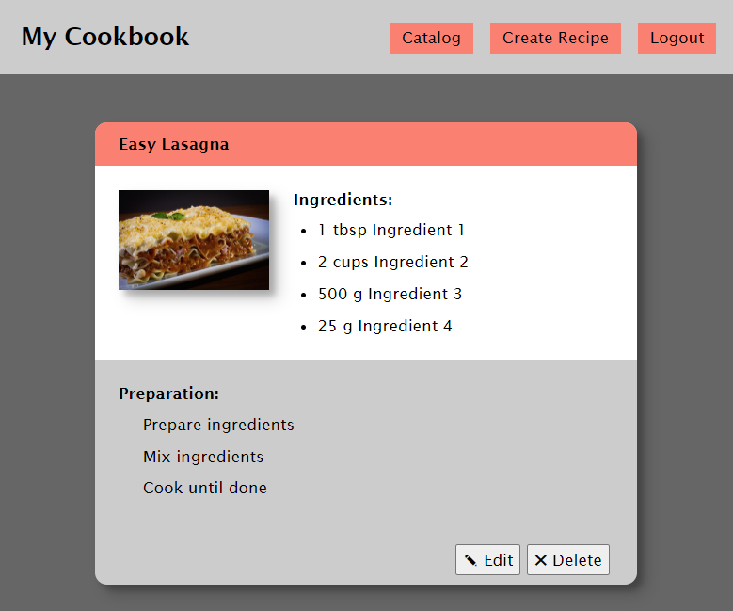

### Edit Recipe (only for the creator)

By clicking on the recipie you can see the details for it, and if you are the creator of this recipe you have to be able to edit and delete it (the two buttons bottom-right are visible)

On click the "Edit" button you are redirected to the edit page and all the details of the recipe should be filled up in the input fields.

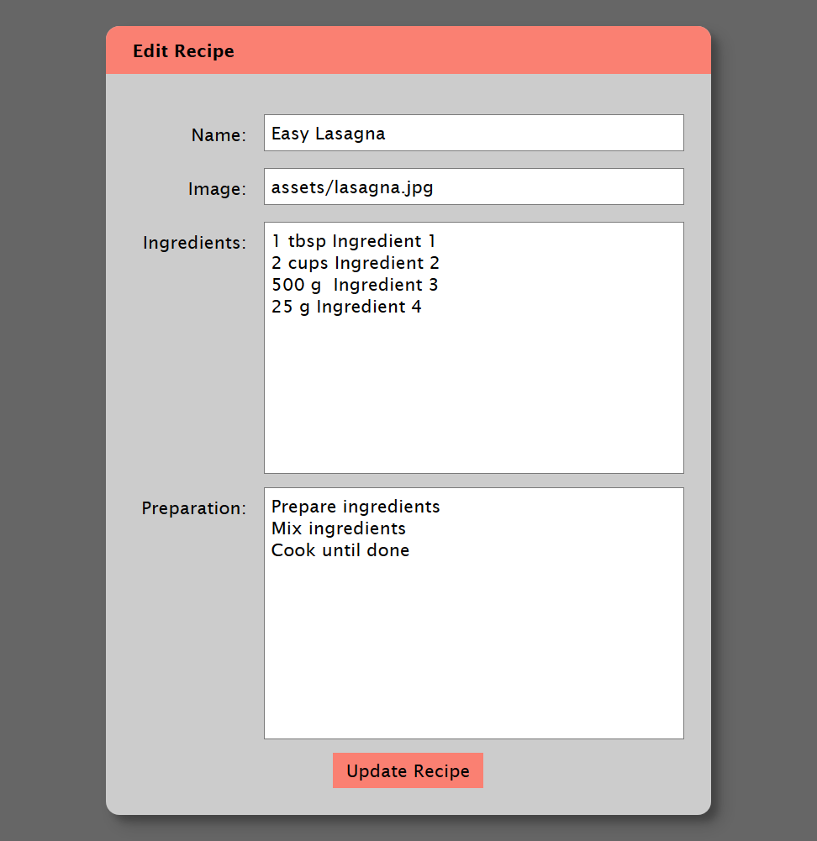

When "Update recipe" button is clicked, the app sends PUT request to the back-end and updates the recipe. After that, redirect to details page.

### Delete Recipe (only for the creator)

By **clicking on "Delete"** button the app needs first confirmation for deleting, then sends DELETE request to the back-end and deletes the recipe. Then the app shows message, that the recipe is deleted successful.

